Das Orchester

Finde die 31 versteckten begriffe in horizontalen, vertikalen und diagonalen reihen

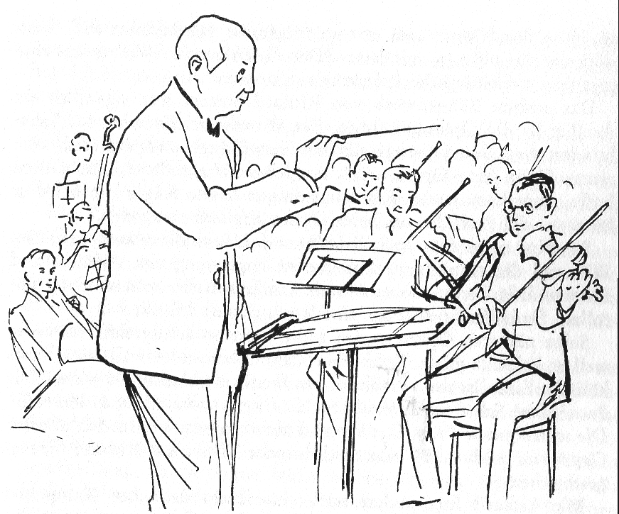
R | E | D | G | G | T | U | I | K | D | M | N | B | V | G | H | G | S | D | E | R | F | G | Z | O
W | i | e | n | e | r | B | P | h | i | l | h | a | r | m | o | n | i | k | e | r | N | T | H | J
V | F | G | T | F | R | D | w | G | R | H | Z | G | T | F | R | D | E | S | W | D | A | N | H | B
N | B | V | C | X | S | D | S | F | I | G | R | U | T | I | T | R | A | P | I | L | O | L | K | K
B | C | F | V | G | B | T | A | R | G | D | A | S | T | R | E | Z | U | I | P | P | O | L | K | J
J | E | O | B | O | E | N | x | B | E | H | Ö | R | N | E | R | N | B | Z | S | E | D | R | F | T
F | T | D | F | F | G | H | N | B | N | H | N | E | M | J | N | H | N | B | G | V | F | C | N | K
D | N | R | T | D | D | D | d | P | T | L | O | S | K | I | J | A | J | P | A | U | K | E | N | M
S | E | A | G | D | T | F | N | V | F | G | B | Ä | N | T | T | Z | I | U | Z | T | N | N | G | P
A | M | C | Z | D | E | T | R | O | M | M | E | L | O | L | K | C | I | J | U | U | H | Z | G | E
N | U | C | g | A | R | V | F | C | D | F | G | B | J | H | C | J | H | G | A | J | H | G | K | T
E | R | I | l | D | S | G | T | F | R | D | E | Z | K | O | K | I | J | S | L | K | J | H | O | N
T | T | R | O | M | P | E | T | E | N | M | K | L | L | N | B | V | O | G | F | D | U | P | N | E
T | S | T | c | u | P | S | R | E | D | R | F | O | H | G | F | P | J | H | G | F | B | D | Z | M
E | N | R | k | T | N | K | I | J | H | G | F | H | N | F | R | D | H | E | D | R | L | U | E | U
N | I | E | e | I | M | F | A | G | O | T | T | P | L | T | O | A | K | I | J | U | E | H | R | R
I | H | A | n | A | O | W | N | P | O | L | O | K | I | J | R | B | G | V | F | C | C | Z | T | T
R | C | S | s | W | I | S | G | E | i | G | E | N | O | F | K | A | I | J | U | H | H | F | M | S
A | I | D | p | S | D | E | E | A | L | N | H | B | E | B | G | H | B | H | T | U | B | A | E | N
L | E | F | i | E | R | D | J | S | L | N | H | B | G | V | F | C | D | Ä | A | S | L | Q | I | I
K | R | G | e | D | F | G | H | D | E | H | Z | G | T | F | R | D | E | D | S | A | Ä | A | S | G
A | T | W | l | R | T | R | B | E | C | K | E | N | U | J | I | K | O | L | S | S | S | E | T | A
w | S | S | E | F | G | n | r | o | h | H | c | s | i | l | G | N | e | S | A | S | E | D | E | L
D | R | A | L | T | H | H | Z | G | T | F | R | E | T | Ö | L | F | R | E | U | Q | R | F | R | C
E | R | B | R | A | T | S | C | H | E | N | B | G | V | F | C | D | F | T | G | Z | H | U | J | S

Streichinstrumente, Geigen, Bratschen, Celli, Kontrabässe, Holzbläser, Piccolo, Querflöte, Oboen, Englischhorn, Fagott, Klarinetten, Blechbläser, Hörner, Trompeten,Posaunen, Tuba, Schlaginstrumente, Pauken, Trommel, Becken, Triangel, Glockenspiel, Harfe, Partitur , Dirigent, Konzertmeister, Tanzplatz, Wiener Philharmoniker, Riccardo Muti

© Hildegard Höhn 2006

