Das Orchester

Finde die 31 versteckten begriffe in horizontalen, vertikalen und diagonalen reihen

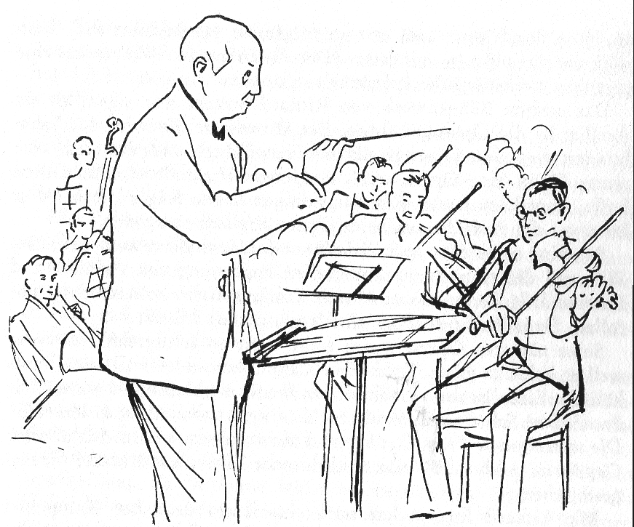
 |  |  |  |  |  |  |  |  | D |  |  |  |  |  |  |  |  |  |  |  |  |  | Z
W | i | e | n | e | r |  | P | h | i | l | h | a | r | m | o | n | i | k | e | r |  | T
 |  |  |  |  |  |  | w |  | R |  |  |  |  |  |  |  |  |  |  |  | A
 |  |  |  |  |  |  | S |  | I |  | R | U | T | I | T | R | A | P |  | L
 |  |  |  |  |  |  | A |  | G |  |  |  |  |  |  |  |  |  | P
 | E | O | B | O | E | N | x |  | E | H | Ö | R | N | E | R |  |  | Z
 | T | D |  |  |  |  | N |  | N |  |  | E |  |  |  |  | N |  |  |  |  |  | N
 | N | R |  |  |  |  | d |  | T |  |  | S |  |  |  | A |  | P | A | U | K | E | N
 | E | A |  |  |  |  | N |  |  |  |  | Ä |  |  | T |  | I |  |  |  | N
 | M | C |  |  |  | T | R | O | M | M | E | L |  |  |  | C |  |  |  | U |  |  |  | E
N | U | C | g |  |  |  |  |  |  |  |  | B |  |  | C |  |  |  | A |  |  |  | K | T
E | R | I | l |  |  |  |  |  |  |  |  | Z |  | O |  |  |  | S |  |  |  |  | O | N
T | T | R | O | M | P | E | T | E | N |  | K | L | L |  |  |  | O |  |  |  |  |  | N | E
T | S |  | c | u |  |  | R |  |  |  |  | O |  |  |  | P |  |  |  |  | B |  | Z | M
E | N |  | k | T |  |  | I |  |  |  |  | H | N |  |  |  | H |  |  |  | L |  | E | U
N | I |  | e | I |  | F | A | G | O | T | T |  |  | T |  | A |  |  |  |  | E |  | R | R
I | H |  | n |  |  |  | N |  |  |  |  |  |  |  | R |  |  |  |  |  | C |  | T | T
R | C |  | s |  |  |  | G | E | i | G | E | N |  | F |  | A |  |  |  |  | H |  | M | S
A | I |  | p |  |  |  | E |  | L |  |  |  | E |  |  |  | B |  | T | U | B | A | E | N
L | E |  | i |  |  |  | L |  | L |  |  |  |  |  |  |  |  | Ä |  |  | L |  | I | I
K | R |  | e |  |  |  |  |  | E |  |  |  |  |  |  |  |  |  | S |  | Ä |  | S | G
 | T |  | l |  |  |  | B | E | C | K | E | N |  |  |  |  |  |  |  | S | S |  | T | A
 | S |  | g |  |  | n | r | o | h | H | c | s | i | l | G | N | e |  |  |  | E |  | E | L
 |  |  | g |  |  |  |  |  |  |  |  | E | T | Ö | L | F | R | E | U | Q | R |  | R | C
 |  | B | R | A | T | S | C | H | E | N |  |  |  |  |  |  |  |  |  |  |  |  |  | S

Streichinstrumente, Geigen, Bratschen, Celli, Kontrabässe, Holzbläser, Piccolo, Querflöte, Oboen, Englischhorn, Fagott, Klarinetten, Blechbläser, Hörner, Trompeten,Posaunen, Tuba, Schlaginstrumente, Pauken, Trommel, Becken, Triangel, Glockenspiel, Harfe, Partitur , Dirigent, Konzertmeister, Tanzplatz, Wiener Philharmoniker, Riccardo Muti

© Hildegard Höhn 2006

