Wassermusik, Feuerwerksmusik und Georg Friedrich händel

Finde die 26 versteckten begriffe in horizontalen, vertikalen und diagonalen reihen

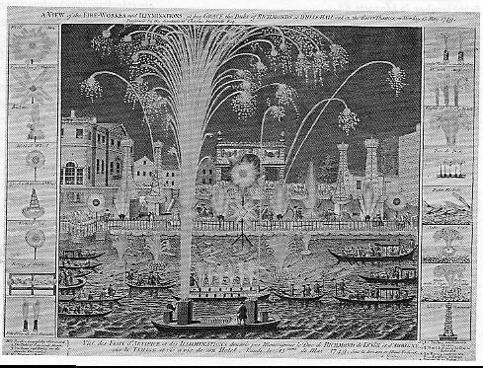
g | f | h | w | n | u | p | d | f | f | g | h | w | e | r | x | c | h | c | a | b | k | r | s | o
e | l | W | e | s | t | m | i | n | s | t | e | r | k | i | r | c | h | e | m | g | e | t | F | a
n | z | a | r | e | g | e | s | l | k | h | e | r | d | f | g | w | e | m | a | s | a | g | r | b
e | a | s | b | z | e | s | t | r | e | i | c | h | e | r | b | s | f | b | p | e | r | a | i | m
r | u | s | l | k | i | s | g | h | t | z | u | o | p | e | r | d | c | a | b | n | a | e | e | w
a | k | e | i | r | t | i | d | f | f | b | n | e | w | e | r | t | x | l | c | v | t | r | d | a
l | e | r | n | i | n | a | g | s | d | l | t | z | t | o | e | t | r | o | m | p | e | t | e | n
b | f | m | d | e | r | s | u | i | d | f | u | n | d | i | e | b | n | r | t | g | c | c | n | s
a | e | u | u | s | r | t | a | d | b | n | f | s | e | r | u | y | x | w | e | r | t | a | s | i
s | i | s | n | g | h | j | k | r | e | r | s | a | s | i | e | s | f | g | h | t | r | e | f | s
s | f | i | g | r | e | e | n | p | a | r | k | w | a | k | t | z | g | h | j | o | s | k | e | e
m | i | k | d | f | r | g | j | g | s | b | c | v | b | r | o | t | z | s | d | f | g | a | i | u
t | z | u | e | y | x | c | v | a | s | m | a | v | g | z | u | n | i | t | e | r | r | f | e | a
p | o | v | e | n | t | i | l | e | s | d | f | n | t | z | u | f | z | h | b | e | o | a | r | a
u | d | f | g | r | e | w | r | d | f | g | z | u | d | p | g | h | j | e | a | t | e | z | u | c
d | f | g | h | i | j | u | e | r | t | a | h | s | u | e | d | f | b | m | r | w | g | e | r | c
z | h | i | u | g | t | d | f | g | c | v | w | a | b | t | z | u | g | s | k | t | g | a | s | d
u | i | o | a | r | x | a | e | f | j | h | o | i | l | k | m | n | a | e | e | i | i | p | a | s
i | i | v | e | t | z | a | l | d | w | p | o | b | i | l | z | u | l | u | i | a | n | t | z | d
a | i | v | c | r | t | z | c | i | s | d | w | e | n | k | e | t | k | l | v | b | e | r | t | a
k | u | d | f | e | n | x | c | w | e | r | f | h | j | k | l | u | z | t | g | h | o | s | d | w
o | z | u | c | d | f | e | e | r | a | n | c | t | z | u | i | k | p | j | k | r | k | s | c | h
u | d | e | o | n | g | e | r | g | h | a | n | d | a | l | a | t | i | n | v | a | l | r | t | u
f | e | u | e | r | w | e | r | k | s | m | u | s | i | k | e | r | g | h | z | a | s | f | e | p
l | i | n | h | o | r | s | t | i | a | l | a | t | a | b | a | r | e | b | n | o | d | n | o | l

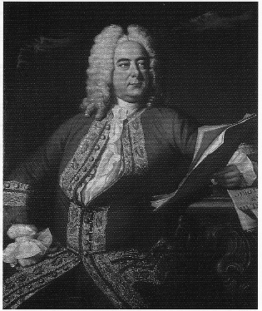
Wassermusik, Flusskonzert,Barke, Feuerwerksmusik,Green Park,Friedensfeier, London, Themse, Halle, König Georg, Oper, Italien, Generalbass, Messias,Oratorium, Dublin, Suite, Sarabande, Trompeten ,Ventile, Hörner,Cembalo, Erblindung,Streicher,Ouverture, Westminsterkirche
© Hildegard Höhn 2006

