Wassermusik, Feuerwerksmusik und Georg Friedrich händel

Finde die 26 versteckten begriffe in horizontalen, vertikalen und diagonalen reihen

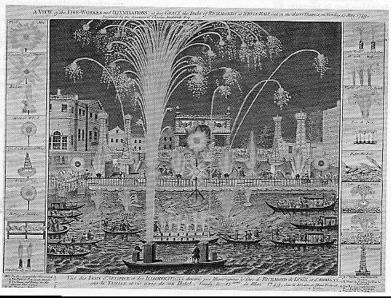
g |  |  |  |  |  |  |  |  |  |  |  |  |  |  |  |  |  | c
e |  | W | e | s | t | m | i | n | s | t | e | r | k | i | r | c | h | e |  |  |  |  | F
n |  | a | r |  |  | e |  |  |  |  |  |  |  |  |  |  |  | m |  |  |  |  | r
e |  | s | b |  |  | s | t | r | e | i | c | h | e | r |  |  |  | b |  |  |  |  | i
r |  | s | l |  |  | s |  |  |  |  |  |  |  |  |  |  |  | a |  |  |  |  | e
a |  | e | i |  |  | i |  |  | f |  |  | e |  |  |  |  |  | l |  |  |  |  | d
l |  | r | n |  |  | a |  |  |  | l |  |  | t |  |  | t | r | o | m | p | e | t | e | n
b |  | m | d |  |  | s |  |  |  |  | u |  |  | i |  |  |  |  |  |  |  |  | n
a |  | u | u |  |  |  | a |  |  |  |  | s |  |  | u |  |  |  |  |  |  |  | s
s |  | s | n |  |  |  |  | r |  |  |  |  | s |  |  | s |  |  |  |  |  |  | f
s |  | i | g | r | e | e | n | p | a | r | k |  |  | k |  |  |  |  |  |  |  |  | e
 |  | k |  |  |  |  |  |  |  | b |  |  |  |  | o |  |  |  |  |  | g |  | i
 |  |  |  |  |  |  |  |  |  |  | a |  |  |  |  | n |  | t |  |  | r |  | e
 |  | v | e | n | t | i | l | e |  |  |  | n |  |  |  |  | z | h | b |  | o |  | r
 |  |  |  |  |  |  | r |  |  |  |  |  | d |  |  |  |  | e | a |  | e
 |  |  |  |  |  | u |  |  |  |  | h |  | u | e |  |  |  | m | r |  | g
 | h |  |  |  | t |  |  |  |  |  |  | a | b |  |  |  |  | s | k | t | g
 |  | o |  | r |  |  |  |  |  |  |  |  | l |  |  |  |  | e | e |  | i
 |  |  | e |  |  |  |  |  |  |  |  |  | i | l |  |  |  |  |  |  | n
 |  | v |  | r |  |  |  |  |  |  |  |  | n |  | e |  |  |  |  |  | e
 | u |  |  |  | n |  |  |  |  |  |  |  |  |  |  |  |  |  |  |  | o
o |  |  |  |  |  | e |  |  |  |  |  |  |  |  |  |  |  |  |  |  | k
 |  |  |  |  |  |  | r
f | e | u | e | r | w | e | r | k | s | m | u | s | i | k
 |  |  |  |  |  |  |  |  |  |  |  |  |  |  |  |  |  |  | n | o | d | n | o | l

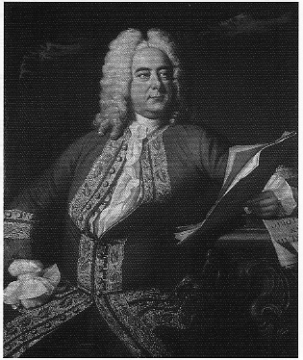
Wassermusik, Flusskonzert,Barke, Feuerwerksmusik,Green Park,Friedensfeier, London, Themse, Halle, König Georg, Oper, Italien, Generalbass, Messias,Oratorium, Dublin, Suite, Sarabande, Trompeten ,Ventile, Hörner,Cembalo, Erblindung,Streicher,Ouverture, Westminsterkirche
© Hildegard Höhn 2006

